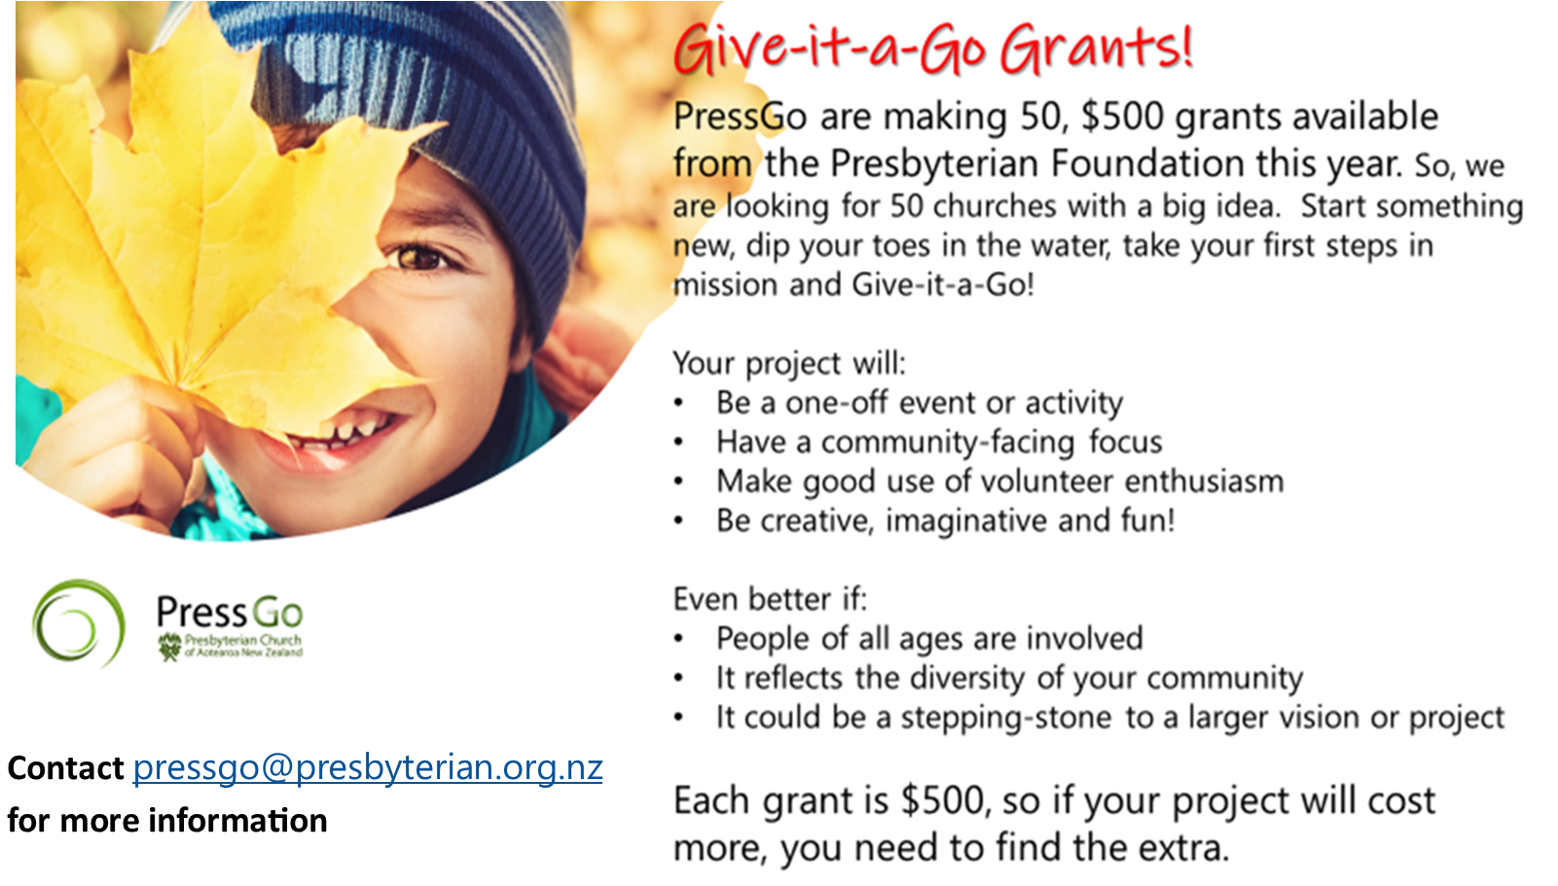
You might like to focus your mission project towards Neighbours Day, Easter, White Ribbon Day, Children’s Day, Halloween, Christmas or another national day and take advantage of other resources and promotions that will occur already at that time.

Applications are open now and will remain so until the 50 grants are awarded. To make sure everyone has the opportunity for a grant, applications are limited to two from each church.

It’s easy, just fill in the form, email to pressgo@presbyterian.org.nz and we’ll let you know by the end of the month. For accountability all you need to do is share your story with us – use words, pictures or make a video clip. We’ll share these with the church to inspire others!

Give-it-a-Go Grants

Applicant Church
Contact name
Contact email
Contact phone

If you are successful in being awarded a grant, which bank account is it to be paid into? (This must be a church or Presbytery account.)
Name on bank account
Number

Give-it-a-Go Grants

What is your big mission idea, when and where would it take place and what would you spend your $500 grant on?

Signature

Name of person signing
Role in church
Date of application

